**Project Documentation**

**🎶 Rhythmic Tunes: Your Melodic Companion 🎶**

**1. Introduction:**

* **Project Title:** **🎶 Rhythmic Tunes: Your Melodic Companion 🎶**
* **Team ID: NM2025TMID36362**
* **Team Leader:**

**Name:** Sanju shree k

**Mail Id:** sanjushreemeena@gmail.com

* **Team Members:**

**1.**Rohini. D - rohinid2007@gmail.com

**2.**Ragavi. S - ragavi0803s@gmail.com

**3.** Saveetha shree .M - @saveetha0007@gmail.com

**4.**Sugitha. P - sugitha0410@gmail.com

**2. Project Overview:**

* **Purpose:** Rhythmic Tunes is a simple and interactive web-based music player that allows users to play songs, search for tracks, and save their favourite songs. It offers a smooth user experience with a stylish UI, background music, and persistent favourites storage using local Storage.
* **Features:**

1. Playlist with multiple songs
2. Search functionality for quick filtering
3. Add/Remove Favourites section (saved permanently in local storage)
4. Background music with autoplay
5. Now Playing display with live updates
6. Responsive and animated gradient background

**3. Architecture:**

* **Frontend:**HTML5, CSS3 (gradient animations, responsive layout)

JavaScript (DOM manipulation, local Storage)

* **Backend:** Not required (Pure client-side application)
* **Database:** Not applicable (Uses browser’s local Storage for storing favourites)

**4. Setup Instructions:**

**Prerequisites:**

* Any modern web browser (Chrome, Edge, Firefox)
* Text editor (VS Code recommended)

**Installation Steps:**

1. Clone or download the project folder
2. Open the index.html file in a browser
3. Enjoy the music player 🎵

**5. Folder Structure:** *Rhythmic-Tunes/*

*│── index.html # Main music player file*

*│── style.css # (Optional: Inline in HTML)*

*│── songs/ # Local MP3 files*

*│── assets/ # (Optional: icons/images)*

**6. Running the Application:**

* **Frontend:** Open index.html directly in the browser
* **Access:** Example: file:///C:/Users/YourName/MusicPlayer/index.html

**7. API Documentation**

* (No backend API. Instead, functions are defined in JS.)
* **Functions:**

play Song (file, title) → Plays selected song

filter Songs () → Filters songs based on search input

addToFavorites(event, file, title) → Adds a song to favourites

saveFavorites() → Stores favourites in local Storage

loadFavorites() → Loads favourites from local Storage

**8. Authentication:**

* Not applicable (Single-user local app, no login required)

**9. User Interface:**

* **Landing Page:** Welcome screen with animated gradient background
* **Playlist Section:** Displays all songs with play buttons
* **Search Box:** Filters songs in real time
* **Favorites Section:** Stores starred songs for easy access
* **Now Playing Section:** Shows the current track playing
* **Audio Player:** Standard HTML5 audio controls

**10. Testing**

* **Manual Testing:** Checked functionality of play, pause, and favourites

Tested search filter with different inputs

Verified local Storage persistence after browser refresh

* **Tools Used:** Chrome Dev Tools (console testing)

Manual browser testing

**11. Screenshot:**

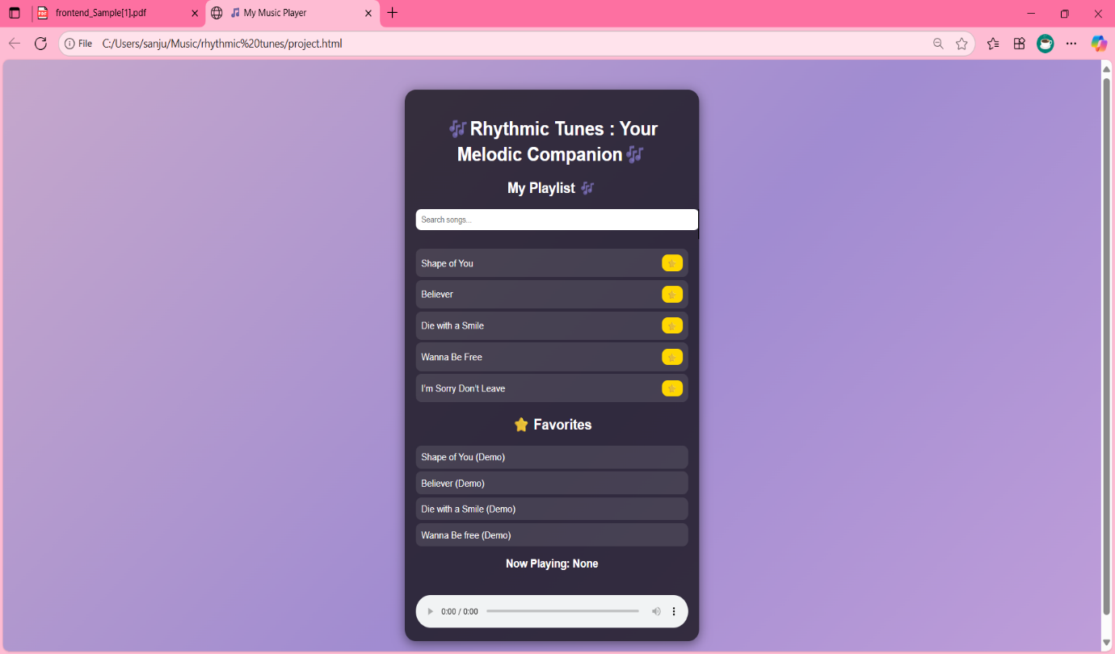

**12. Known Issues:**

* Local MP3 file paths may not work when shared across different devices (use relative paths or online links for portability).
* Autoplay background music may be blocked in some browsers due to restrictions.

**13. Future Enhancements:**

* Add backend support with user login and personalized playlists
* Implement remove option for favourites
* Support for multiple playlists
* Add shuffle and repeat options
* Mobile app version using React Native